**Control Panel of Robot**

**Outline:**1- What is the task?  
2- What tools did I use?  
3- Code explained  
4- Code output  
5- Conclusion  
  
**1. What is the task?**  
The first task is to design a webpage for a simple robot control panel using HTML & CSS languages

2. What tools did I use?  
The tools used in this task are:  
1. Elzero web school (YouTube channel) To explain.  
  
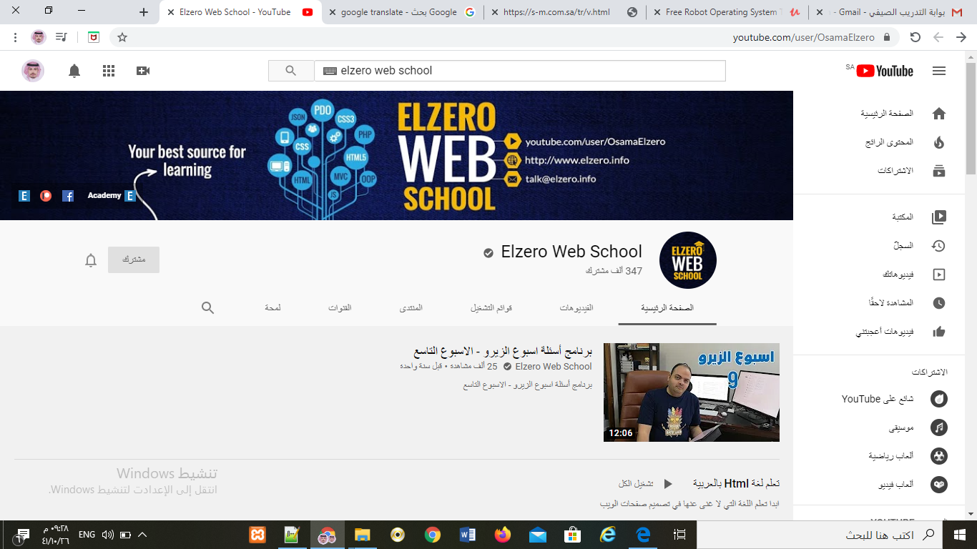  
  
  
  
  
  
2. HTML For construction  
  
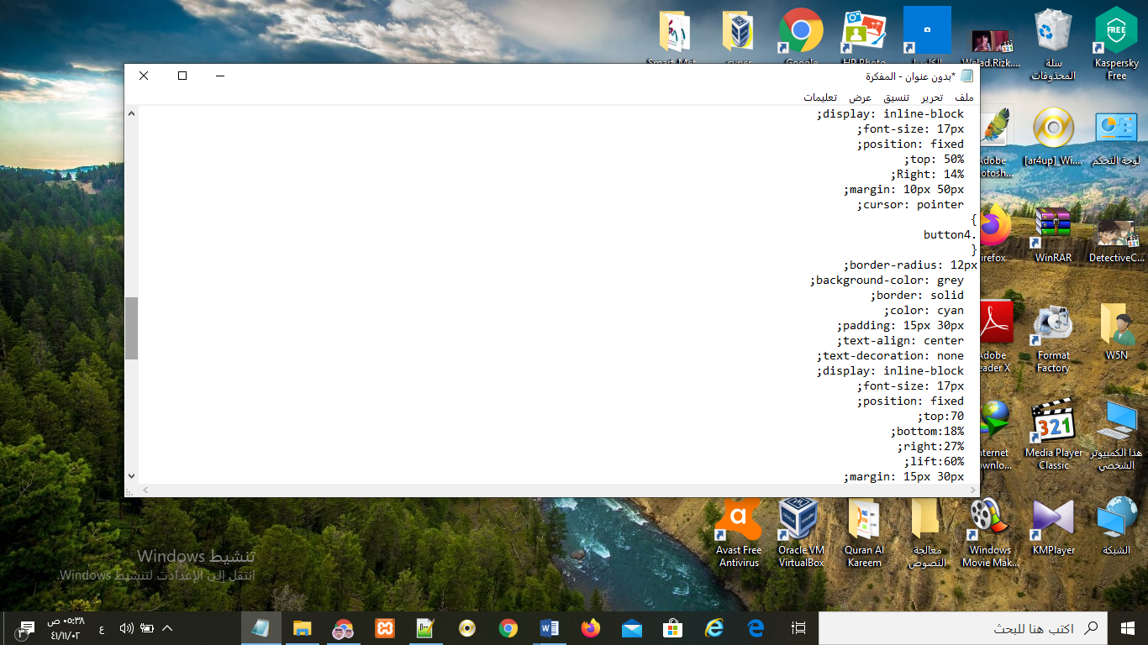

3. CSS for design.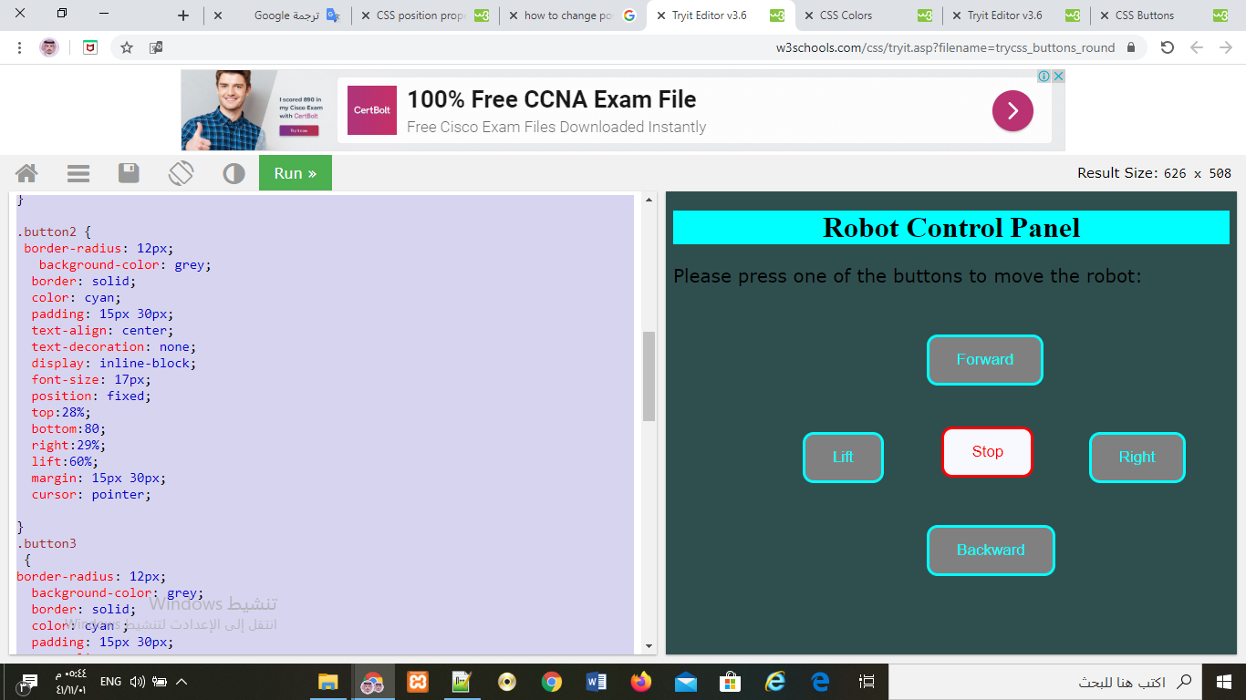

.  
  
  
4. Xampp for testing.  
  
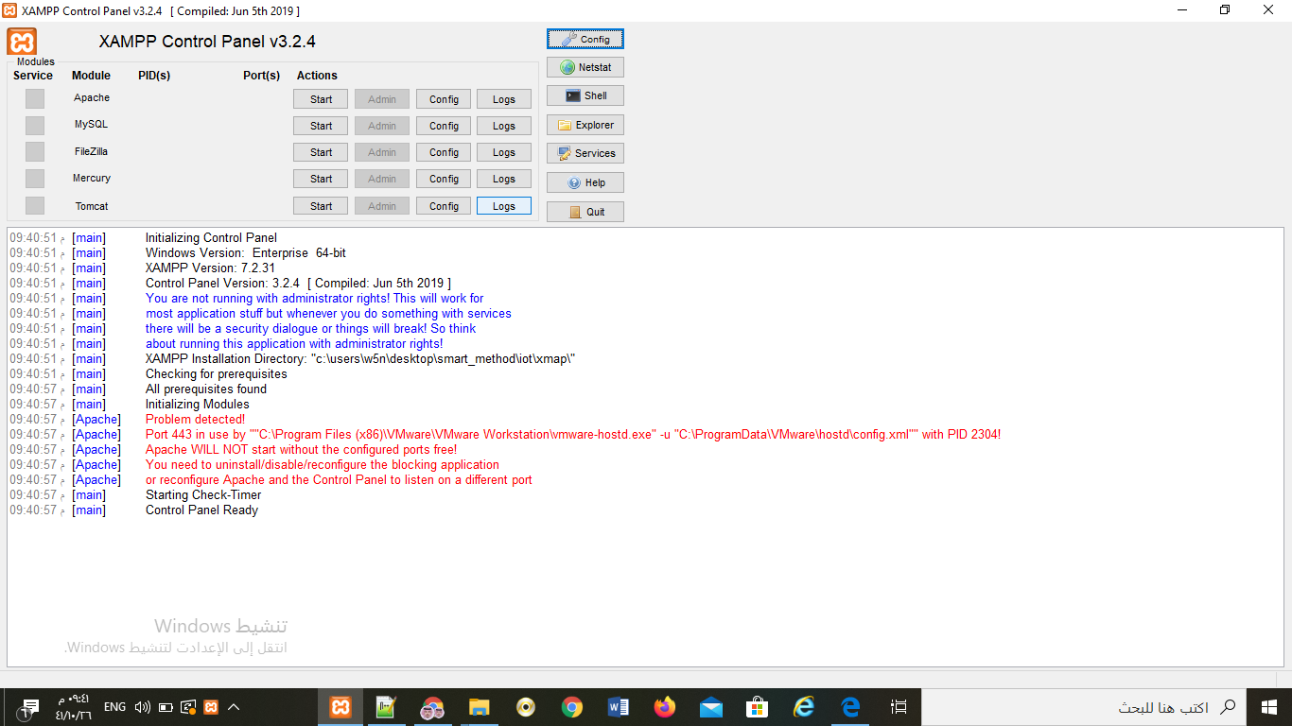

3. Code explained,1. I used 2 web designlanguages (HTML & CSS)  
  
<!DOCTYPE html>

<html>

<title>Robot Control Panel</title>

<head>

<style>

Body {

background-color: lightblue;

}

h1{

color: Black;

} text-align: center;

P {

font-family: verdana;

} font-size: 20px;

</style>

2. I used the previous code to put a page title, edit the header style and edit it on the page background.  
  
.button1 {

border-radius: 12px;

background-color: GhostWhite;

border: solid;

color: red;

padding: 15px 30px;

text-align: center;

text-decoration: none;

display: inline-block;

font-size: 17px;

position: fixed;

top: 50%;

left: 61%;

margin: 5px 5px;

cursor: pointer;

}  
  
  
3. I used the previous code to change the style, size and position of buttons  
  
<h1 style="background-color:cyan;"> Robot Control Panel</h1>

<p>Please press one of the buttons to move the robot:</p>

4. I used the previous code to put a title, edit the style and color of the title in the body, and put an explanatory paragraph   
  
  
  
  
  
  
  
<button class="button button1">Stop</button>

<button class="button button2">Forward</button>

<button class="button button3">Right</button>

<button class="button button4">Backward</button>

<button class="button button5">Lift</button>

5. I used the previous code to create and name buttons

4. Code output:  
  
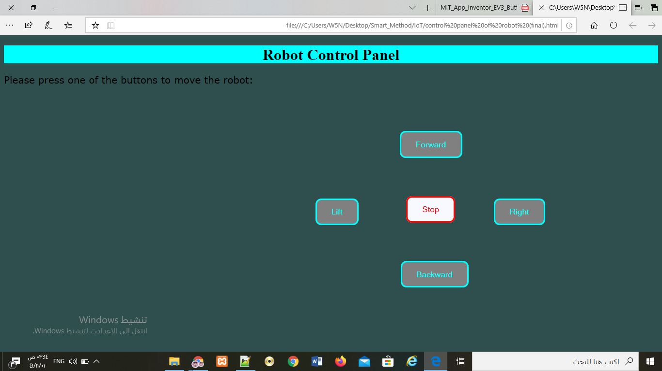

5. Conclusion,

In conclusion, In this task I use ( Elzero web school) to learning and  
 I use ( Notbad++) to editing the code and I use ( Html & Css) to design web page and I use ( Xampp) local host to testing and I use ( screenshot) to explain my points.